Political Philosophers of the Ancient World

Confucius Epicurus
Han Fei (Han Feizi) Thales of Miletus
Hammurabi Zeno of Elea or Zeno of Citium (Stoic founder)
Socrates Laozi
Plato
Aristotle
Cicero
Chanakya
Socrates
Mozi
Xenophon
Diogenes of Sinope
Aeschines
Mencius
Xun Zi
Thiruvalluvar
Pliny the Younger
Pythagoras
Political Philosopher Wall of Fame Displays
You will be creating a display for the wall outside our classroom that will show major political philosophers, their beliefs, and their political impacts throughout human history. You will be provided with a square of paper and on it you must:
- Include birth and death dates & where he/she was born (2pts)
- Include 3 facts about the person’s personal life – need to be important/formative (3pts)
- Include a picture or drawing of your person – this can be hand-created or printed; stylization is encouraged (artistic filter, cartoon, comic book style, etc.) (4pts)
- Include 3 political beliefs (6pts)
- Include 2 major impacts the person’s beliefs had on history or later politics (4pts)
- Include one quote that provides an example of the person’s beliefs (3pts)
Example:
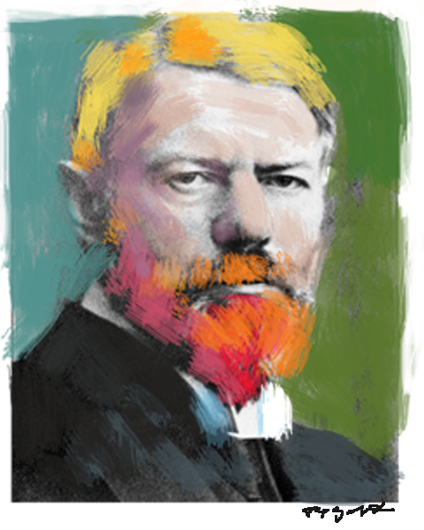
Max Weber
Major Political Theories:
- Distinguished 3 ideal types of political leadership domination: charismatic (familial & religious), traditional (patriarchs, feudalism) & legal (modern law & state, bureaucracy)
- Defines “the state” as that entity which possesses a delegatable monopoly on the legitimate use of physical force
- Says an ideal bureaucracy is characterized by hierarchical organization, expert training, and career advancement depending on qualifications
Impact on Society: Regarded as one of the founders of modern sociology and heavily influenced the later 20th century philosopher Leo Strauss
Quote: “One can say that three pre-eminent qualities are decisive for the politician: passion, a feeling of responsibility, and a sense of proportion.”
Born: 1864 in Germany Died: 1920
Personal Life:
- Considered rude by his teachers because he read all 40 volumes of philosopher Goethe instead of doing other school work
- Received a doctorate in law from the University of Berlin in 1189
- Married Marianne Schnitger, a feminist activist and author who published Weber's journal articles after his death and her biography of him is an important source for understanding Weber's life

Political Philosopher Wall of Fame Displays – Grade Sheet Name ________________________
_____ Include birth and death dates & where he/she was born (2pts)
_____ Include 3 facts about the person’s personal life – need to be important/formative (3pts)
_____ Include a picture or drawing of your person – this can be hand-created or printed (4pts)
_____ Include 3 political beliefs (6pts)
_____ Include 2 major impacts the person’s beliefs had on history or later politics (4pts)
_____ Include one quote that provides an example of the person’s beliefs (3pts)
_____ Total Points (out of 22) Grade: __________

Political Philosopher Wall of Fame Displays – Grade Sheet Name ________________________
_____ Include birth and death dates & where he/she was born (2pts)
_____ Include 3 facts about the person’s personal life – need to be important/formative (3pts)
_____ Include a picture or drawing of your person – this can be hand-created or printed (4pts)
_____ Include 3 political beliefs (6pts)
_____ Include 2 major impacts the person’s beliefs had on history or later politics (4pts)
_____ Include one quote that provides an example of the person’s beliefs (3pts)
_____ Total Points (out of 22) Grade: __________

Political Philosopher Wall of Fame Displays – Grade Sheet Name ________________________
_____ Include birth and death dates & where he/she was born (2pts)
_____ Include 3 facts about the person’s personal life – need to be important/formative (3pts)
_____ Include a picture or drawing of your person – this can be hand-created or printed (4pts)
_____ Include 3 political beliefs (6pts)
_____ Include 2 major impacts the person’s beliefs had on history or later politics (4pts)
_____ Include one quote that provides an example of the person’s beliefs (3pts)
_____ Total Points (out of 22) Grade: __________

