Name:________________________________
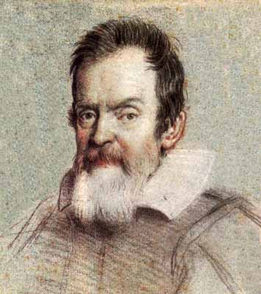
Getting to Know Galileo – A Webquest
Directions: Save this document to your student drive. Click on the links and begin typing your responses after my questions in a different color of your choosing (make sure it is readable). Answer all questions in your own words. DO NOT copy and paste…or else…
Background
Go to http://en.wikipedia.org/wiki/Heliocentrism and spend some time reading about Heliocentrism.
- In your own words, what is heliocentric theory? Who developed it?
- What theory proposes the opposite of heliocentrism? What does it say? Who developed it?
- Why was heliocentrism so controversial? (You can’t find this answer in the article – think for yourself!)
His Life
Go to: http://www.pbs.org/wgbh/nova/galileo/ and explore the “Galileo’s Place in Science” link
- What subject was Galileo passionate about? Hint: it’s what he believed was his biggest contribution.
- What field was Galileo’s father in, which first stirred his passion on this subject?
- Go back and explore the link about “Galileo’s Telescope” by clicking on “Support Materials” then “Background Essay”. How much was Galileo able to magnify (how many times) with his first version of the spyglass-turned-telescope?
Go to: http://galileo.rice.edu/chron/galileo.html#1610 and scroll down to read about these dates’ events.
- What important discovery did Galileo make in January of 1610?
- Read about April of 1624. Under what condition does the Pope allow Galileo to write about Copernican theory?
- What does the Inquisition do to Galileo after he publishes Dialogue Concerning Two Chief World Systems? Start reading in 1632.
- Continue reading through 1633. What does Galileo do as a result?
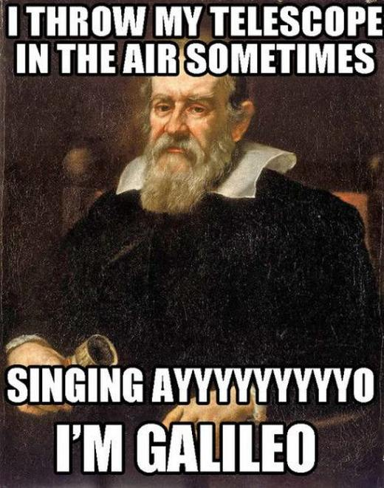
- After his battle with the Inquisition, how does Galileo spend the rest of his life? (December 1633)
Go back to the NOVA page to do some of Galileo’s experiments: http://www.pbs.org/wgbh/nova/physics/galileo-experiments.html
- Click on the “Launch Interactive” link and go through his experiments. How did you do? What did you learn?
Modern Views
Go to: http://en.wikipedia.org/wiki/Galileo_Galilei and click on the “Church reassessments of Galileo in later centuries” link in the contents list (under legacy).
- How did Pope John Paul II feel about Galileo?
- Scroll down to “Impact on modern science.” What do Steven Hawking and Albert Einstein think about Galileo?
Submit this document to adkinsah@spart6students.org by attaching it to an email. It will be worth 20 points.

